Carbon Brush Holder for ALCO & DMW Locomotives
We supply Carbon Brush Holders for ALCO and DMW locomotive applications, designed for reliable performance and proper carbon brush positioning.
- Suitable for ALCO & DMW Locomotives
- Robust construction for locomotive applications
- Ensures proper brush alignment and reliable current collection
- Available as per required specification and application
Quality Products | Reliable Supply | Prompt Service
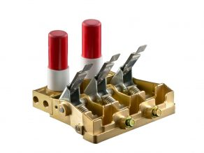 | 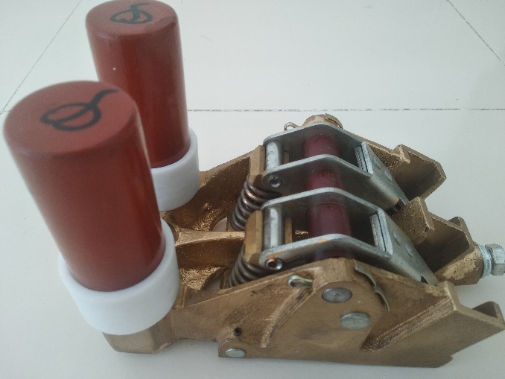
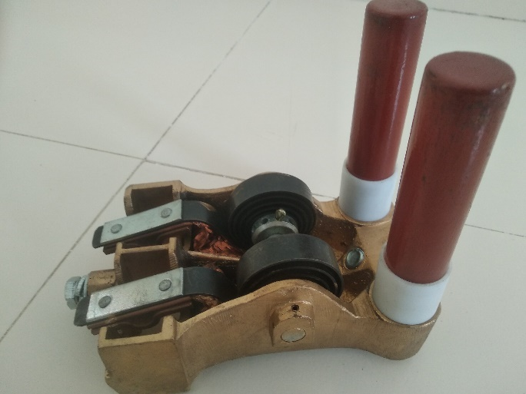 | 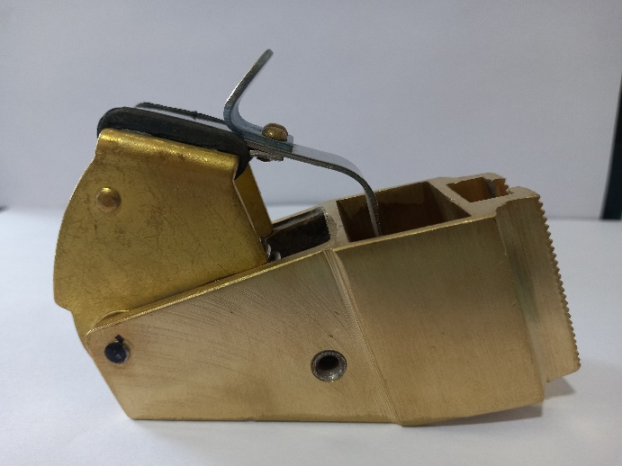

SEO - keywords like ALCO locomotive carbon brush holder, DMW locomotive carbon brush holder, locomotive carbon brush holder

